2.5: In time t the fast runner has traveled 200 m farther than the slow runner:
.
Fast runner has run 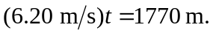
Slow runner has run 